**Lab 5 Activity 3 - Using SmartArt and Charts**

**Objective** - Develop skills to visually organize information and represent data effectively using SmartArt and charts

1. Insert a SmartArt graphic to represent a process or hierarchy. Learn to use SmartArt for illustrating processes, workflows, or organizational structures in a clear and professional manner.
2. Add a chart (e.g., bar or pie chart) and input sample data. Practice creating and customizing charts to represent data visually, improving comprehension and impact during presentations

**____________________________________________________________________________________**

**Solutions:**

**Task 1:**

* Select the content you want to convert into smart art.
* Go to Insert tab, then Smart Art in the illustrations pane.
* Select your preferred design.
* Enter

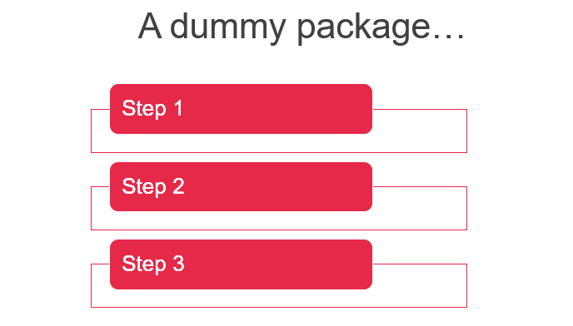

**Task 2:**

* Select the data you want to convert into a chart.
* Go to Insert tab, then Chart in the illustrations pane.
* Select your preferred design.
* Enter
* You can also add data manually in excel sheets.

